# Sprint 1

## User Stories

|  |  |  |  |  |
| --- | --- | --- | --- | --- |
| ID | User Story Name | User Story Description | Priority | Estimated Effort(Hours) |
| 1 | Choose a board size | As a player, i want to choose a n*n board so that i can play whatever size board | Low | 1 |
| 2 | Choose the game mode of a chosen board | As a player, i want to choose between general and simple game mode so i can play with different rules | MID | 1 |
| 3 | Start a new game of the chosen board size and game mode | As a player, I want to click start with the chosen game board size and mode so i can play the game | HIGH | 2 |
| 4 | Make a move in a simple game | As a player, I want to be be able to place an S or O, on an empty space so i can spell out SOS and win | HIGH | 4 |
| 5 | A simple game is over | As a player, I want the game to end after SOS is spelled out, so I can see who won | HIGH | 4 |
| 6 | Make a move in a general game | As a player, I want to be able to place an S or O on the board in the general game mode so I can attempt to form multiple SOS sequences and increase my score. | High | 4 |
| 7 | A general game is over | As a player, I want the general game to end when all spaces are filled, so the total number of SOS sequences can be counted and the winner can be determined. | High | 4 |

|  |  |  |  |
| --- | --- | --- | --- |
| User Story ID and Name | AC ID | Description of acceptance criteria | Status (completed,toDo,inProgress) |
| Choose a board size | 1.1 | AC 1.1 Show board size selection  Given the start screen is visible  When the player selects board size  Then the UI must show that it has accepted the input | To do |
| 1.2 | AC 1.2 Create grid with size n  Given the player has input the size of the the board  When a new game starts  Then a board the size n*n will show with empty squares |
| Choose the game mode of a chosen board | 2.1 | AC 2.1 Show buttons for modes  Given the start screen is visible  When the player selects the game mode  Then the game mode selected is the only one applied | To do |
| 2.2 | AC 2.2 general game is chosen  Given player chose general game mode  When a new game starts  Then the rules for general games are applied |
| 2.3 | AC 2.3 Simple game is chosen  Given player chose simple game mode  When a new game starts  Then the rules for general games are applied |
| Start a new game of the chosen board and game mode | 3.1 | AC 3.1 New game  Given the input for board size and game mode  When the player clicks play game  Then the board shows up with all empty squares and correct size and rules | To do |
| Make a move in a simple game | 4.1 | AC 4.1 Valid selection  Given its the players turn in simple mode  When the player selects an empty square  Then the correct symbol ‘S’ or ‘O’ will appear where selected | To do |
| 4.2 | AC 4.2 Invalid selection  Given its the players turn in simple mode  When the player selects an occupied square  Then the UI will show that it can not place a symbol there and wait for valid input |
| A simple game is over | 5.1 | AC 5.1 Winner  Given a simple game as started  When a move spells out “SOS”  Then the game ends and UI announces winner | To do |
| 5.2 | AC 5.2 TIE  Given a simple game has started  When all sqaures are filled with no “SOS” spelled out  Then the game ends and UI announces a TIE |
| Make a move in a general game | 6.1 | AC 6.1 Valid input  Given it is the player’s turn in general mode When the player selects an empty square and places an S or O Then the symbol appears, and the system checks for any new SOS sequences, updating the score if found. | To do |
| 6.2 | AC 6.2 Invalid input  Given it is the player’s turn in general mode When the player selects an occupied square Then the UI shows that the move is invalid and waits for valid input. |
| A general game is over | 7.1 | 7.1 Winner  Given a general game has started When all squares are filled and one player has more SOS sequences than the other Then the game ends and the UI announces the player with the highest score as the winner. | To do |
| 7.2 | 7.2 Tie  Given a general game has started When all squares are filled and both players have the same number of SOS sequences Then the game ends and the UI announces a TIE. |

# ChatGPT Screenshots/Description

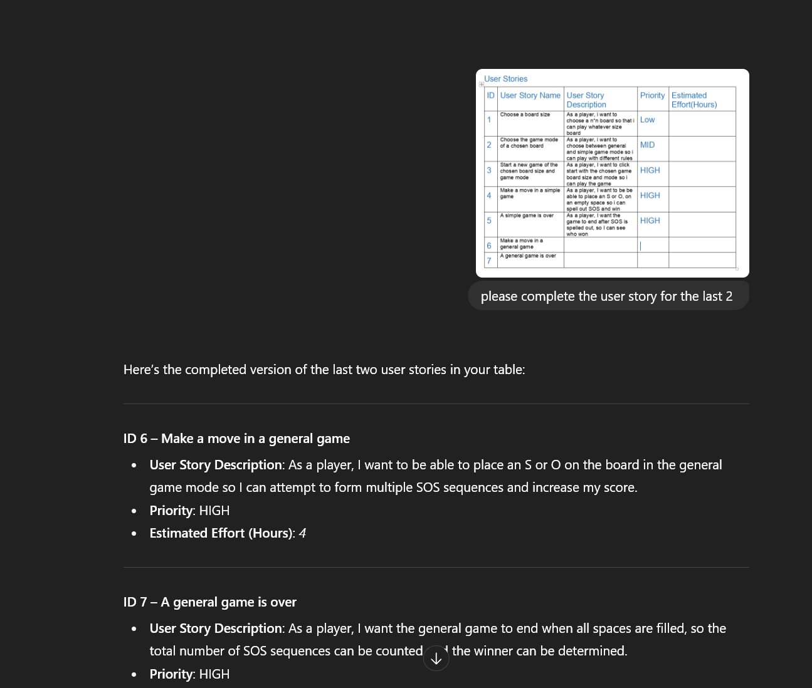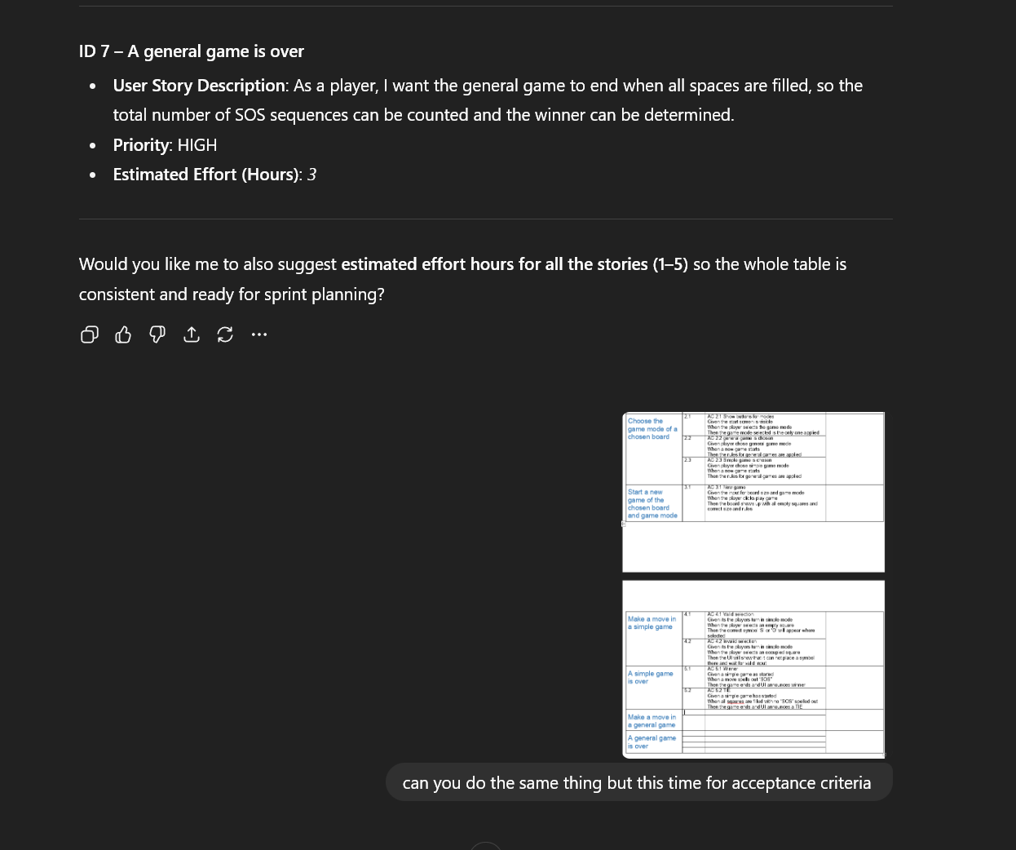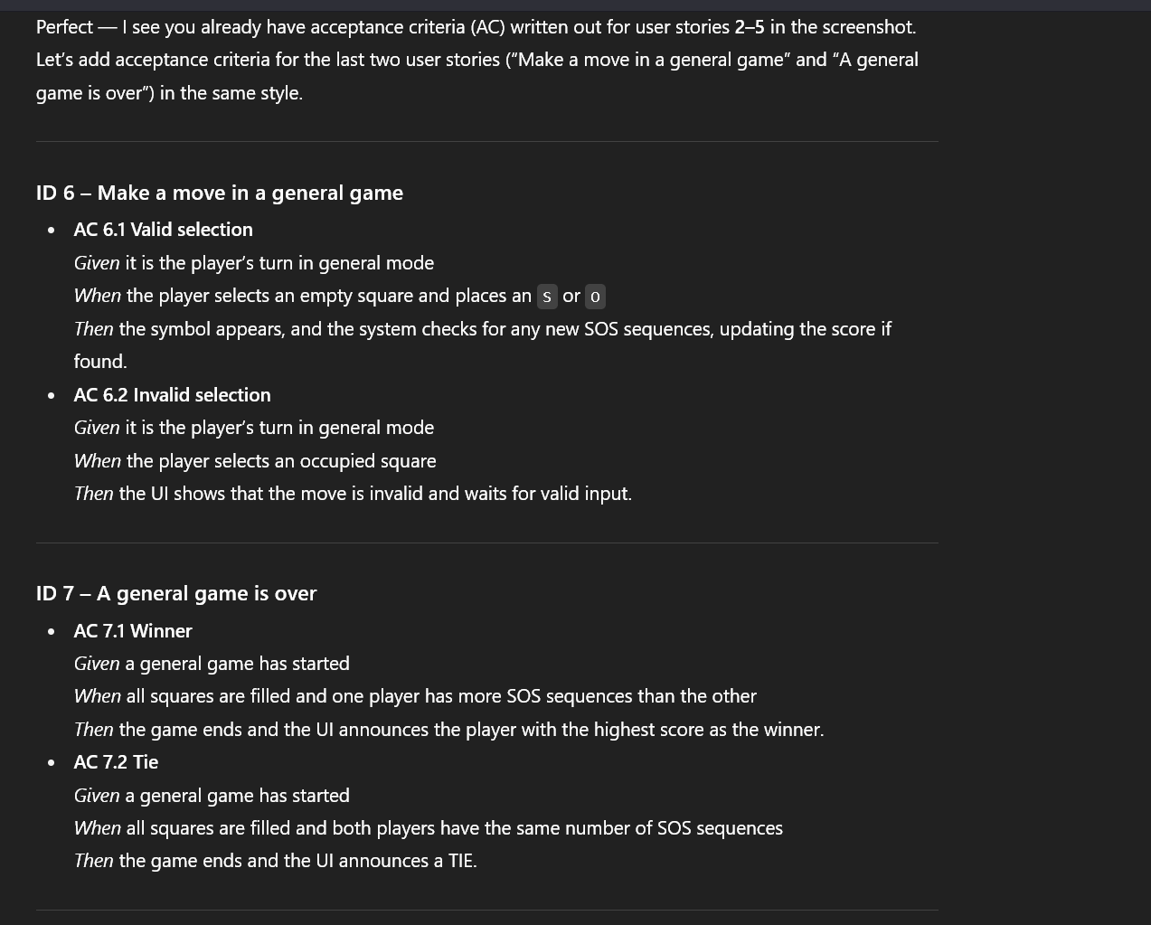

## Description:

I dont believe there were any errors with what ChatGPT gave me. Probably because it was able to see what i had done first and stuck to that format.